IoT-Driven Adaptive Solar Energy Management System with Intelligent Load Prioritization and Web-Enabled Monitoring

ª Dr Hariprabhu Manoharan ^{b} Ms Kaviya Gunasekaran ^{c} Mr Kesavan Adaikapitchai
Assistant Professor/Electrical And BE. Electrical And Electronics Engineering BE. Electrical And Electronics Engineering
Electronics Engineering M. Kumarasamy College of Engineering M. Kumarasamy College of Engineering
M. Kumarasamy College of Engineering Karur, Tamil Nadu Karur, Tamil Nadu
Karur, Tamil Nadu kaviyadhina2005@gmail.com sgkesavan6gmail.com@gmail.com
hariprabhum@gmail.com

^{d} Mr Mahendran Sundararajan
BE. Electrical And Electronics Engineering
M. Kumarasamy College of Engineering
Karur, Tamil Nadu
smahendran.2006@gmail.com

Abstract— The‍‌‍‍‌‍‌‍‍‌ primary aim of the proposed project is to develop an innovative, safe, and energy-efficient solar power system using IoT technology. The central unit, which basically represents the brain of the entire setup, is an ESP32 microcontroller that continuously communicates with the sensors measuring the voltage and current of the solar panel and the battery. After that, the controller is performing battery charge and discharge operations in a smart manner, and also it guarantees that the energy kept is the one that is used for different electrical loads, and it is doing this based on the priority levels of the different ‍‌‍‍‌‍‌‍‍‌loads. Essential​‍​‌‍​‍‌​‍​‌‍​‍‌ loads such as essential lights or important appliances are given the first power, while other loads are allowed to run only if there is a surplus of power production. By​‍​‌‍​‍‌​‍​‌‍​‍‌ means of IoT connectivity, people can monitor the solar generation rate, the battery condition, and the power consumption via a smartphone or web application. Besides that, the machine has been equipped with a battery overcharge, over discharge, and output short circuit protection component. This infrastructure can be readily expanded and applied to diverse facilities like homes, hospitals, schools, and offices where uninterrupted power supply is critical. When combining the renewable energy with smart control and monitoring, however, the proposed system ensures a low-cost, flexible, and environmentally friendly way to manage solar power efficiently. It is a supporter of sustainable energy and also provides an example of how IoT can help in better distribution of power usage, which can make energy more secure for current applications.

Keywords: ESP32 microcontroller, smart load prioritization, battery protection system, IoT-based energy management.

I. INTRODUCTION
​‍​‌‍​‍‌​‍​‌‍​Solar‍‌‍‍‌‍‌‍‍‌ energy is rapidly becoming one of the most reliable renewable resources; however, traditional solar systems are often energy inefficient in that they merely generate and store power without managing the distribution of the power to the connected loads. Thus, when the sunlight is weak or the battery is low, essential appliances may happen to be disconnected, and the users will not obtain any real-time information on solar production, battery levels, or energy consumption. These drawbacks lower the system's reliability and become a source of energy wastage and battery over-discharge. The IoT-Driven
Adaptive Solar Management System comes with the solution to these problems, which is to make the use of solar power more intelligent and dependable. The solar panel and battery monitoring system of an ESP32 microcontroller, along with voltage and current sensors, is what the system constitutes. The entire solar, battery, and load data are uploaded to the cloud; thereby, the users have access via the mobile or web interface to the remote monitoring of solar production, battery status, and load activity. One of the significant contributions of the proposed system is the smart load prioritization algorithm by which appliances are classified into critical, medium, and luxury loads. In low-energy conditions, critical loads are powered on non-stop; at the same time, medium and luxury loads are turned on only when there is enough solar or battery power. This guarantees that energy will be better utilized, the battery will not be over-discharged, and the reliability of the system will increase. The present model that integrates solar generation, battery storage, IoT-based monitoring, and smart load control is an effective, easy-to-use, and eco-friendly energy management solution. It​‍​‌‍​‍‌​‍​‌‍​‍‌ has a design suitable for different applications like homes, schools, offices, hospitals, and small-scale industries, where there is a need for the supply of clean and reliable energy. Simply,‍‌‍‍‌‍‌‍‍‌ it is an IoT system that can be utilized to optimize the use of renewable energy sources, reduce the reliance on the grid, and facilitate the gradual transition to a sustainable and technologically advanced ​‍​‌‍​‍‌​‍​‌‍​‍‌‍‌‍‍‌‍‌‍‍‌‍‌‍‍‌‍‌‍‍‌future.

II. LITERATURE SURVEY
In​‍​‌‍​‍‌​‍​‌‍​‍‌ most cases, the scientists have been very creative in coming up with ideas related to IoT-controlled solar energy. The three topics they have focused on are efficiency monitoring, intelligent load control, and system reliability. The single publication of Rao et al. (2024) [1] unveils a smart IoT-based monitoring system that can be employed for solar PV generation. The authors have been able to pinpoint that the whole energy usage process becomes more efficient when very up-to-the-minute voltage and current measurements are made. Similarly, Rani et al. (2023) [2] have developed an IoT photovoltaic energy granularity system that not only tracks the energy output but also collects the system health data, which, in turn, facilitates the system performance measurement to become more accurate. Malatji et al. (2017) [3] have conceived a load-prioritization plan for the households that are located in off-grid areas, and subsequently, they have apportioned solar energy among essential and non-essential loads in a manner that is effective. As a result of their work, forecasting-based load optimization has been introduced, and photovoltaic installations are now capable of giving detailed scheduling of energy consumption according to the expected availability, as was pointed out by Rao et al. (2024) [4]. In order to elucidate this topic, Nath et al. (2024) [5] have compiled a review paper presenting the advantages brought about by the integration of the Internet of Things (IoT) in solar-powered areas, e.g., improved monitoring, fault detection, and remote access, which are more user-friendly and convenient.
Chinnathambi​‍​‌‍​‍‌​‍​‌‍​‍‌ et al. (2022) [6] are the authors that came up with the concept of a smart residential building EMS, which not only changes the load between the solar PV and the grid automatically but also does it dynamically by employing IoT-based control logic. Alhafidh et al. (2023) [7] have developed a sustainable energy prioritization scheme that is capable of performing the energy resource allocation task for residential loads in an efficient manner while also considering the factors of reliability and energy delivery ​‍​‌‍​‍‌​‍​‌‍​‍‌​‍​‌‍​‍‌​‍​‌‍​‍‌optimization.

III. EXISTING METHOD OF IOT-ENABLED IMPLEMENTATION OF A SMART ENERGY MANAGEMENT SYSTEM FOR REAL-TIME MONITORING AND CONTROLLING

This​‍​‌‍​‍‌​‍​‌‍​‍‌ paper is about the development of a system based on IoT that can both monitor and control the use of electrical energy in real-time. It achieves this by connecting the electrical loads of a household or an industry to an Arduino microcontroller and an IoT platform. So, the users can not only see the power consumption but also have the freedom to manage the loads by themselves from a remote location via the internet. The system is set up to do the work of turning the loads ON or OFF automatically if it is time, consumption, or peak hours that are chosen as the preset conditions. Thus, it helps in the elimination of steps in power consumption that are unnecessary, in the reduction of electricity bills, and in the enhancement of the energy efficiency level. The whole installation is intended to be a smarter, more efficient, and easily accessible energy management solution made possible by IoT ​‍​‌‍​‍‌​‍​‌‍​‍‌technology. Furthermore,​‍​‌‍​‍‌​‍​‌‍​‍‌ the system lacks an intelligent load prioritization feature, meaning that all appliances are treated equally, regardless of the amount of energy available.
Since no solar-based decision-making is involved, the device cannot adjust power allocation according to the state of the battery or solar ​‍​‌‍​‍‌​‍​‌‍​‍‌situation.
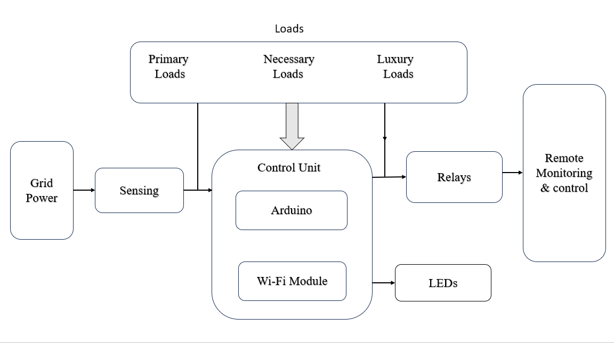
Figure 1: Block Diagram of the Existing IoT-Based Smart Energy Management System

As Figure 1 shows, the​‍​‌‍​‍‌​‍​‌‍​‍‌ present system aims to keep track of energy consumption and limit it as per requirement. It specifies the use of the Internet of Things (IoT) technology. After lightning, the power is given on the control panel; the power-controlled unit takes the power from the main power supply and provides it to different loads. Electronic measurement devices get the load, the voltage, and the current values and transfer them to the microcontroller of the Arduino. The Arduino microcontroller is the one that processes the given data and does the controlling work of the system. According to the given data, the Arduino microcontroller controls the execution of the program depending on the priority levels of the loads. Furthermore, it is attached to a Wi-Fi module that puts the data on an IoT platform, making it possible for the users to watch and operate devices from a distance through a mobile or internet application. The users are three groups. These are the primary, necessary, and luxury consumables. Primary loads like lights and fans are energized first, necessary ones are powered only when there is enough energy, and luxury loads are used only when there is extra energy. Relays are actuators installed in the loads that change the state of the loads to ON or OFF according to control signals from the Arduino. LEDs have the ability to give a visual indication of the working status of the system. The whole system is a method to lessen the load of the power grid and at the same time help that can be controlled from a distance.

IV. PROPOSED METHOD: IOT-DRIVEN ADAPTIVE SOLAR MANAGEMENT SYSTEM WITH INTELLIGENT LOAD PRIORITIZATION AND WEB-ENABLED MONITORING

The​‍​‌‍​‍‌​‍​‌‍​‍‌ main goal of the proposed system is to effectively handle solar energy through the use of IoT technology and intelligent control. For this, the authors have utilized an ESP32 microcontroller interfaced with some voltage and current sensors for measuring solar power generation, battery power, and load conditions in real time. After that, the system will decide the power consumption depending on the availability of energy by first supplying the essential loads and then the medium and luxury loads. Users can also see the status and issue commands over the internet through a website or mobile app. The installation is similarly equipped with some protective measures against overcharge and deep discharge of the battery. In a nutshell, this model is a smart, inexpensive, and sound way to solve the problem of energy supply from solar sources, with intelligent load control and IoT-based ​‍​‌‍​‍‌​‍​‌‍​‍‌monitoring.

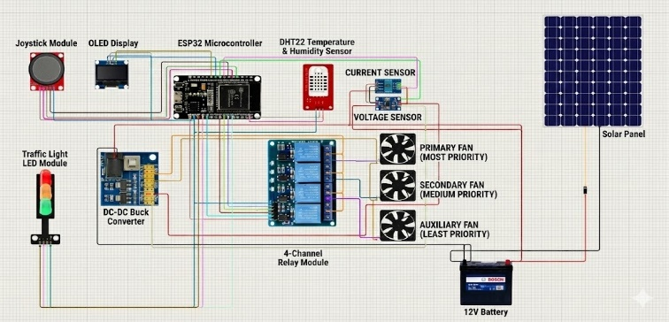

Figure 2: Circuit Diagram of the IoT-Driven Adaptive Solar Management System

Figure​‍​‌‍​‍‌​‍​‌‍​‍‌ 2 shows the complete electrical working of an IoT-based solar power management system and tells how each component helps the smart energy distribution. The solar panel is the starting point of the system; its output is controlled through a DC-DC buck converter, and then a 12V battery is ​‍​‌‍​‍‌​‍​‌‍​‍‌charged. During this, the voltage and current sensors are always measuring the solar panel’s input as well as the battery’s condition. These real-time parameters are then sent to the ESP32 microcontroller, which is the central decision-making unit. Based on the sensor data, the controller, through a 4-channel relay module, thus manages three categories of loads, i.e., primary, secondary, and auxiliary, according to their priority and energy availability. If​‍​‌‍​‍‌​‍​‌‍​‍‌ a joystick module could be employed for manual adjustment of the loads in situations of necessity, and the traffic-light LED indicators were to provide a real-time visual representation of the loads that were running, then it would appear to be a fantastic arrangement. The entire thing is visually depicted on an OLED display, which shows the current solar voltage, battery, and load condition, whereas IoT connectivity is like a key for remote monitoring and control of the entire system via an online dashboard in real-time. This figure conveys the smart device as the implemented system that integrates sensing, control, and communication to achieve efficient solar power ​‍​‌‍​‍‌​‍​‌‍​‍‌management.

A. MODE OF OPERATION

MODE 1: Solar Active Mode (Φ)

Basically​‍​‌‍​‍‌​‍​‌‍​‍‌ this power generation system is indicative of the usage of solar energy (Φ) as the leading source of power. In the case of good weather, the photovoltaic (PV) panel is irradiated by the sun, and as a consequence, the PV panel delivers electrical energy to the plant. After that, the energy that has just been produced is given to the essential and medium-priority loads only, while the rest of the power is injected into the rechargeable battery for further use in the management ​‍​‌‍​‍‌​‍​‌‍​‍‌​‍​‌‍​‍‌​‍​‌​‍​‍‌system. To be able to do this continuously under different situations, such as temperature or irradiance changes, the ESP32 microcontroller carries out Maximum Power Point Tracking (MPPT) to keep the PV system at the operating point where it is able to get maximum ‍‌‍‍‌‍‌‍‍‌energy.

$$P_{Φ}=V_{Φ}×I_{Φ}$$

$E_Φ = ∫[t₀ to t₁] P_Φ(t) dτ$ ... (1)
Where:
- $E_{Φ}$: Total solar energy generated (J)
- $P_{Φ}$: Instantaneous solar power (W)
- $V_{Φ}$: Solar panel voltage (V)
- $I_{Φ}$: Solar panel current (A)
- $τ$: Time duration (s)
This​‍​‌‍​‍‌​‍​‌‍​‍‌ is mainly done with renewable solar energy; the system is off the grid and only uses the centralized power system, like a grid, when it's absolutely necessary, and energy efficiency is maximized in this mode.

MODE 2: Battery Supply Mode (β)

When​‍​‌‍​‍‌​‍​‌‍​‍‌ solar radiation is weak or absent, such as at night or during a cloudy day, the system will automatically switch to battery mode (β). The battery that was charged during Mode 1 will be discharged to supply the loads that are connected to the system. The ESP32 microcontroller monitors the DC output to be of the same value at all times, and it also protects the battery from deep discharge, which may reduce the battery life. The control circuit is adjusting the power by changing the PWM duty cycle of the converter to maintain the output ​‍​‌‍​‍‌​‍​‌‍​‍‌voltage.

Pβ=Vβ×Iβ

$E_β = ∫[t₀ to t₁] P_β(t) dτ$…(2)
Where:
- $P_{β}$: Instantaneous battery power (W)
- $V_{β}$: Battery voltage (V)
- $I_{β}$: Battery current (A)
- $E_{β}$: Energy released from the battery (J)
The system that is turned on in this mode guarantees the operation of the most necessary appliances with electric energy even when solar radiation is not available; thus, it increases the safety of the system.

MODE 3: IoT Control Mode (Ψ)

The​‍​‌‍​‍‌​‍​‌‍​‍‌ Internet of Things (IoT) control mode (Ψ) is the main factor in system automation as well as monitoring. In fact, the sensors are continuously measuring all the electrical parameters in real-time, such as voltage, current, and power flow. The ESP32 microcontroller then processes these parameters. Based on this information, the system decides which loads are to be prioritized.
For example:
- First of all, critical loads (lights, fans) are always powered.
- Next, medium loads (computers, chargers) get power if there is enough energy available.
- Furthermore, luxury loads (air conditioners, decorative lights) are turned on only if there is surplus energy.
The data that has been measured is sent through a Wi-Fi connection to a cloud-based dashboard from where the users can keep track of solar generation, battery condition, and load behavior by using either a web or a mobile ​‍​‌‍​‍‌​‍​‌‍​‍‌interface.

$$PΣL​=PΦ​+Pβ​-Pλ​$$

$η_{sys}=\frac{P_{ΣL}}{(P_{Φ}+P_{β})}×100\%$ ... (3)
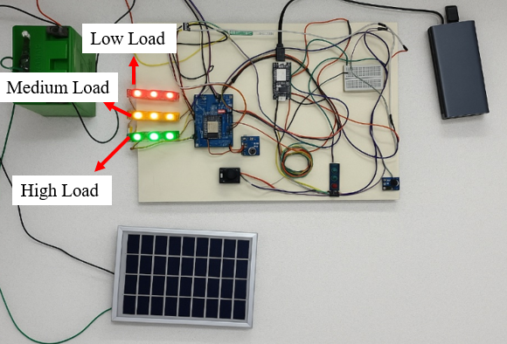
Where:
- $P_{ΣL}$: Total load power consumption (W)
- $P_{λ}$: Power loss in the system (converter and wiring) (W)
- $η_{sys}$: Overall system efficiency
The control based on the IoT allows the users to operate the system remotely and provides the possibility of making quick real-time and energy distributions, which is most advantageous and results in a more efficient and greener ​‍​‌‍​‍‌​‍​‌‍​‍‌operation.
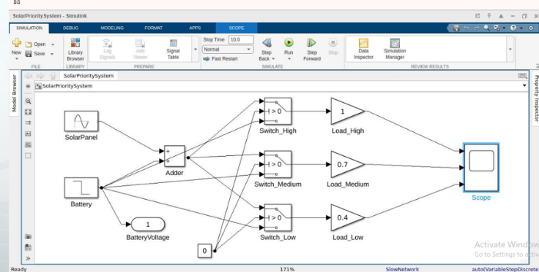
Figure 3: Simulation Model of the IoT-Driven Adaptive Solar Management System
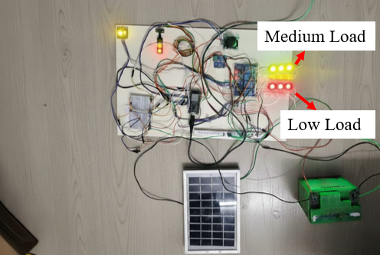
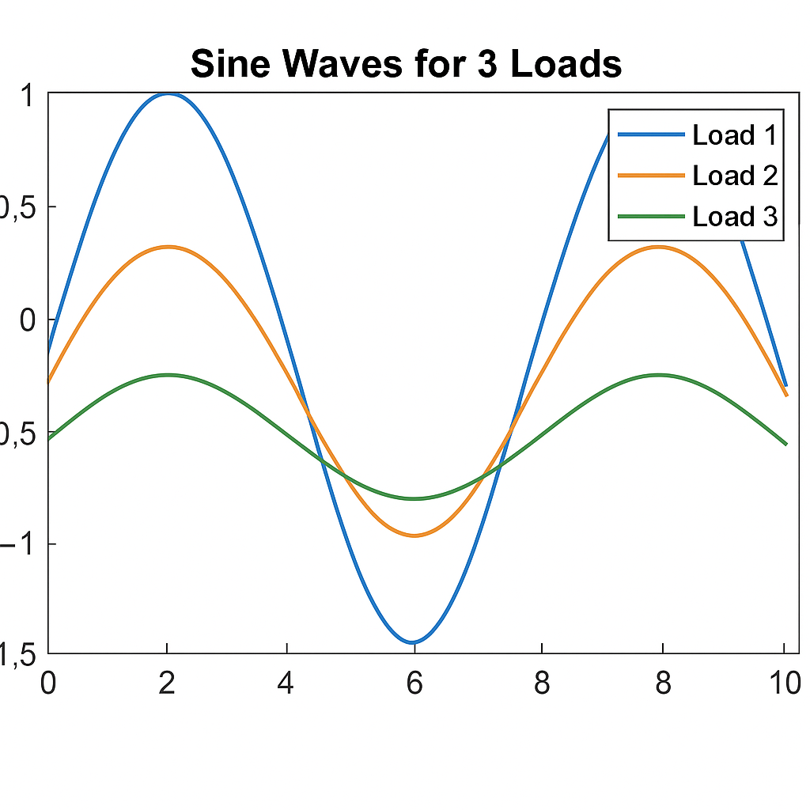
Figure​‍​‌‍​‍‌​‍​‌‍​‍‌ 3 depicts the working of the IoT-Driven Adaptive Solar Management System with the solar panel and battery as the two main power sources. Their outputs are merged through an adder block and sent to the loads of high, medium, and low priority. Each load is turned on through logical switches, which run only when the solar and battery voltages are at the required threshold ​‍​‌‍​‍‌​‍​‌‍​‍‌level.
Figure 4: Output Waveform of Load Switching in the IoT-Driven Adaptive Solar Management System
Figure​‍​‌‍​‍‌​‍​‌‍​‍‌ 4 illustrates the output waveform of the IoT-Driven Adaptive Solar Management System, which is instrumental in visually understanding the method wherein the load switching is carried out from the energy that is available. The waveform is the evidence that high-priority loads are those that are powered constantly, whereas medium and low loads are merely switched on if there is enough solar or battery ​‍​‌‍​‍‌​‍​‌‍​‍‌energy.
V.​‍​‌‍​‍‌​‍​‌‍​‍‌ RESULT AND DISCUSSION
As Figure 5 illustrates, when​‍​‌‍​‍‌​‍​‌‍​‍‌ the battery charge reached 100%, the system realized that there was sufficient energy to supply all load categories. Accordingly, the controller turned on all three loads—high, medium, and low ​‍​‌‍​‍‌​‍​‌‍​‍‌priority. The smart load–priority algorithm checked that the energy level was enough, so it did not restrict any load. Hence, the system is effectively using the total battery capacity and is capable of maximum load operation when the power is available to a significant ‍‌‍extent.
Figure 5: Load Activation Status When Battery Level Reaches 100%
Figure 6 depicts ‌‍‍‌‍‌‍‍‌the battery reaching approximately 75% capacity; the system will automatically prioritize high essential loads. Essential loads (high-priority loads) are still OFF because there is already enough power, so the medium-priority and low-priority loads are still active. This is a guarantee of safety in operation with energy consumption under control and, at the same time, a protection of the battery against fast discharging, which is not ‍‌‍‍‌‍‌‍‍‌wanted.
Figure 6: Medium and Low Priority Load Activation at 75% Battery Capacity
In figure 7, if​‍​‌‍​‍‌​‍​ the battery capacity reaches 40% or less, the device will automatically activate a low-energy protection mode. In this case, the control unit is only allowed to connect the low-priority load, while the medium- and high-priority loads are disconnected in order not to cause the battery to be discharged quickly. Thus, the system remains functional with minimum power consumption, and at the same time, at least one essential basic load is kept alive. By limiting the majority of loads, the battery is guarded against deep discharge, and the backup time is extended in the presence of a low-energy​‍​‌‍​‍‌​‍​‌‍​‍‌situation.
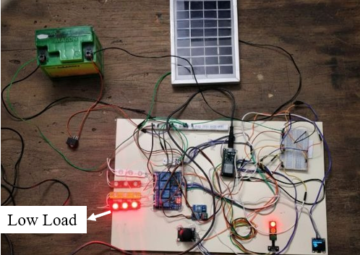
Figure 7: Low-Priority Load Operation During Low Battery Condition (≤ 40%)

Figure 8 shows Additionally, the loads of the given system may be manually manipulated through the use of a joystick module. Upon the user's joystick movement, a control signal is dispatched to the ESP32, which in turn commands the relay module to perform the activation or deactivation of the load. In this way, the user is enabled to bypass the automatic IoT-based priority switching and directly control any load with the help of the joystick. The latter is a perfect solution for the quick change of operations during testing or the occurrence of an emergency, while the ESP32 still keeps an eye on the system, ensuring it is ​‍​‌‍​‍‌​‍​‌‍​‍‌safe.
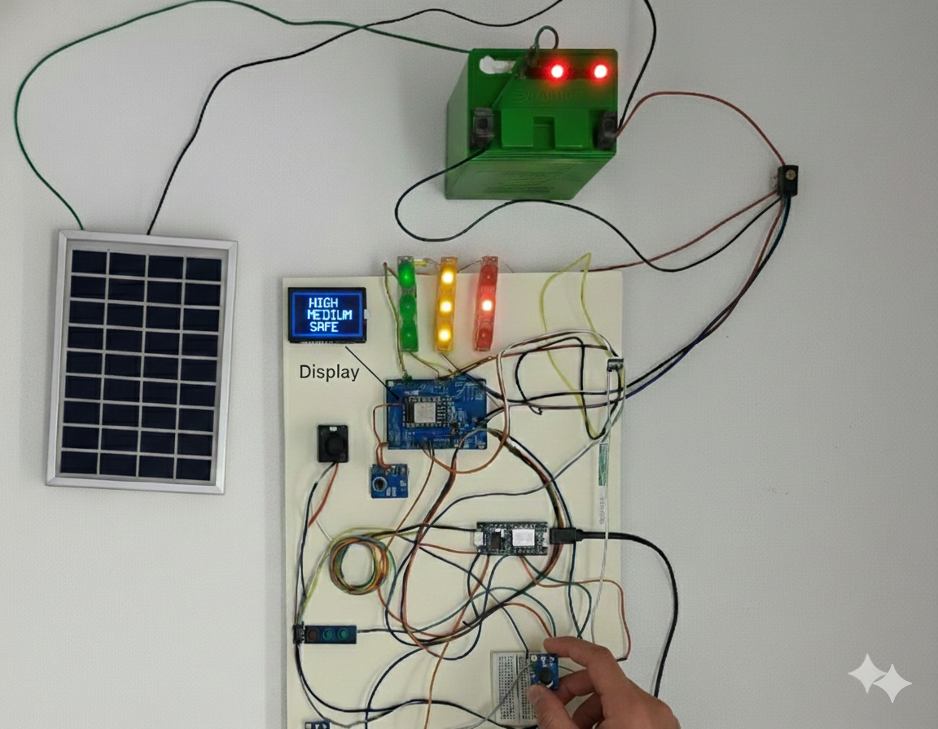
Figure 8: Manual Load Switching Using Joystick Control in ESP32-Based Solar Management System

Figure 9 shows the Through​‍​‌‍​‍‌​‍​‌‍​‍‌ an IoT dashboard on a smartphone, a user is capable of remotely turning ON or OFF any of the loads linked via the ESP32 controller. The mobile application transmits the command to the server, and the ESP32 gets it immediately via Wi-Fi. The controller here is the one to switch ON/OFF the relays that are connected with the load after it receives the command. In this way, a person can take control of heavy, middle, and light loads at any time and from any place without the necessity of a manual operation; thus, the device is a flexible, convenient, and complete automatic ​‍​‌‍​‍‌​‍​‌‍​‍‌system.
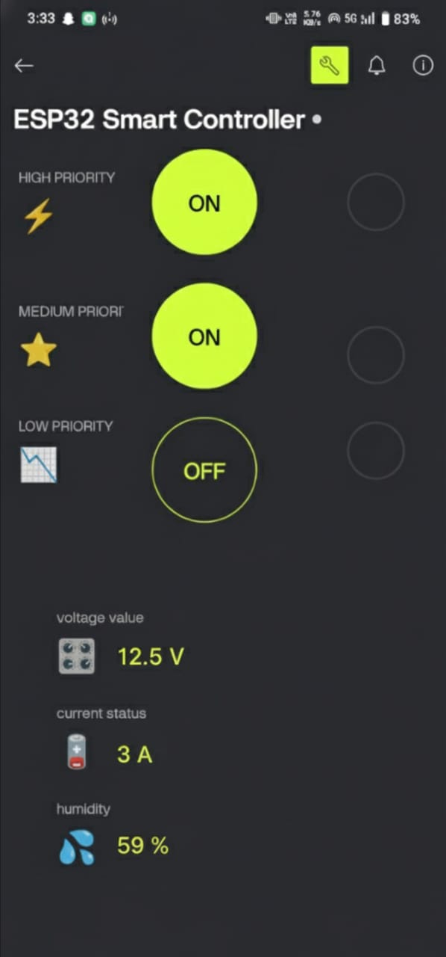
Figure 9: Mobile-Based IoT Load Switching Through Web Dashboard

In Figure 10, with​‍​‌‍​‍‌​‍​‌‍​‍‌ the help of the mobile dashboard, a user is in a position to have a glance at all the vital system parameters instantaneously in a real-time manner. The dashboard exhibits solar voltage, battery voltage, and load status, as well as the system's current priority mode. Through it, the user is enabled to see if the loads are ON or OFF, the battery charge level in percentage, and the power output of the solar panel. Such a kind of remote monitoring is very helpful to the user in grasping the system's performance without a direct interaction with the hardware. In addition, it facilitates speedy decision-making by giving off energy and load activity updates, which are, essentially, situations of a ​‍​‌‍​‍‌​‍​‌‍​‍‌kind.
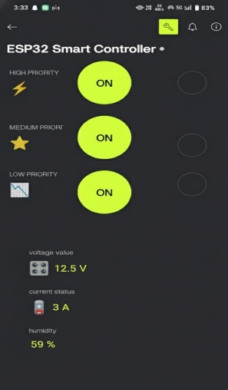
Figure 10: Mobile Dashboard View for Real-Time System Monitoring

Figure 11 shows the​‍​‌‍​‍‌​‍​‌‍​‍‌ IoT-driven adaptive solar management system developed was able to monitor solar input, battery status, and load behaviour in real time. The system included a feature for automatic load prioritization according to the available energy and the battery percentage. When the battery was at full charge (100%), all loads were allowed to continue; that is, the controller made use of power in an efficient ​‍​‌‍​‍‌​‍​‌‍​‍‌way. At around 75% of the battery, only high-priority and medium-priority loads were allowed to be turned on so that the battery would not be discharged unnecessarily. The system, when the battery level reached 40% or less, went into a protection mode and allowed only low-priority essential load, thereby preventing deep discharge and battery backup time extension. The values in real-time, such as solar voltage, battery voltage, and load status, were also shown on the IoT dashboard; thus, sensing and communication performance were reliable. In short, the battery-powered system was used for stable operation, smart energy utilization, and effective load management under different battery conditions. ​‍​‌‍​‍‌​‍​‌‍​‍‌
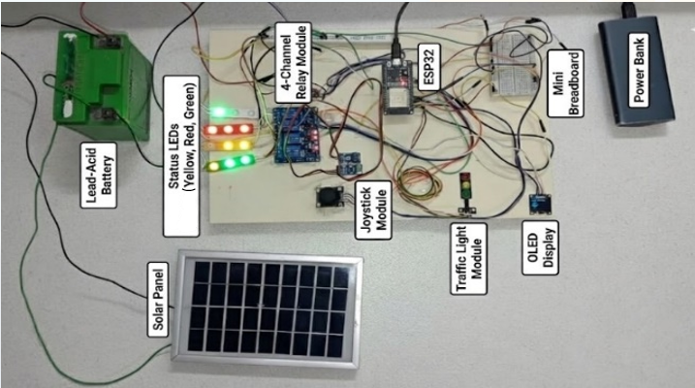Figure 11: Prototype of IoT-Driven Adaptive Solar Management System with Intelligent Load Prioritization.

VI. COMPARISON TABLE

TABLE 1. Comparison Chart Comparing the Parameters of the Existing IoT-Based Solar System and the Proposed IoT-Driven Adaptive Solar Management System

Parameter | Existing IoT-Based Solar System | Proposed IoT-Driven Adaptive Solar Management System
Response Time | 80–100 ms | 30–50 ms
System Stability | Moderate | High
Voltage Regulation | ±2–3% | ±0.5–1%
Energy Utilization (%) | 70–80% | 90-95%
Battery Protection | Basic | Advanced
IoT Monitoring | Limited | Real-time monitoring and control via web dashboard/mobile app
Load Management | Manual or fixed-priority loads | Intelligent automatic switching based on load priority
Charging Efficiency | 65–75% | 85–90%
Scalability | Suitable only for small systems | Scalable for homes, schools, and industrial setups
CONCLUSION

The​‍​‌‍​‍‌​‍​‌‍​‍‌ research shows the IoT-Driven Adaptive Solar Management System as a green and clean tech solution to the problem of managing solar energy in the real world. Through ESP32-based monitoring, priority-based load control, and automated battery protection, the system can be able to deliver power without a stoppage and, at the same time, maximize the use of the available solar ​‍​‌‍​‍‌​‍​‌‍​‍‌energy. The real-time IoT dashboard is like a window that is always open and through which users can see solar voltage, battery status, and load operation. Hence, they can make correct decisions and also remotely supervise the system. Experimental trials have shown that the system decides correctly to switch to solar or battery modes depending on the availability of energy and that it can keep the essential loads even when there are fewer charging conditions. The smart prioritization unit is a waste energy minimization tool that also lengthens the battery life and makes the system more reliable than a standard solar one. In sum, the designed system is a solution that is feasible, can be scaled up, and is environmentally friendly for use in smart homes, educational institutions, and the industry; thus, it is in line with the trend of renewable energy usage and IoT-based ​‍​‌‍​‍‌​‍​‌‍​‍‌automation.

REFERENCES
[1] C. K. Rao, S. K. Sahoo, and R. Mishra, “An IoT-Based Intelligent Smart Energy Monitoring System for Solar PV Power Generation,” Energy Harvesting and Solar Systems, vol. 12, no. 1, pp. 45–54, Jan. 2024.

[2] D. D. P. Rani, D. Suresh, P. R. Kapula, and C. H. M. Akram, “IoT-Based Smart Solar Energy Monitoring Systems,” Materials Today: Proceedings, vol. 68, no. 3, pp. 1120–1127, Mar. 2023.
[3] A. Malatji, O. Popoola, and G. Binini, “Load Prioritization for Maximization of Solar Energy Source in Rural Households,” in Proc. Int. Conf. Domestic and Commercial Use of Energy, Cape Town, South Africa, 2017, pp. 120–125.

[4] C. K. Rao, S. K. Sahoo, and F. F. Yanine, “An IoT-Enabled Energy Management System with Precise Forecasting and Load Optimization for PV Power Generation,” Proceedings of the Indian National Academy of Engineering, vol. 50, no. 2, pp. 211–220, Feb. 2024.

[5] D. C. Nath, I. Kundu, A. Sharma, and P. Shivhare, “Internet of Things Integrated with Solar Energy Applications: A State-of-the-Art Review,” Environmental Science and Pollution Research, vol. 31, no. 7, pp. 15560–15575, Feb. 2024.
[6] N. D. Chinnathambi, K. Nagappan, and P. Venkatesan, “IoT-Based Smart Residential Building Energy Management System for a Grid-Connected Solar PV-Powered DC Building,” Int. J. Energy Res., vol. 46, no. 9, pp. 11234–11248, Sept. 2022.
[7] B. M. H. Alhafidh, R. M. Hagem, and M. Qassab, “Privileging and Prioritizing Processes of Sustainable Energy Resources for Residential Loads,” Iraqi J. Sustainable Energy, vol. 5, no. 1, pp. 15–25, Jan. 2023.
[8] S. Aslam, H. Herodotou, S. M. Mohsin, and N. Javaid, “A Survey on Deep Learning Methods for Power Load and Renewable Energy Forecasting in Smart Microgrids,” Renewable and Sustainable Energy Reviews, vol. 144, pp. 110–127, Apr. 2021.

[9] D. Thomas, O. Deblecker, and C. S. Ioakimidis, “Optimal Operation of an Energy Management System for a Smart Building Considering PV Uncertainty and Electric Vehicle Driving Patterns,” Applied Energy, vol. 228, pp. 1181–1193, Oct. 2018.

[10] S. Panda, I. S. Samanta, and P. K. Rout, “Priority-Based Scheduling in Residential Energy Management Systems Using Adaptive Salp Swarm Algorithm,” Results in Engineering, vol. 25, pp. 102–110, Feb. 2024.

[11] H. Ismail, I. Jahwar, and B. Hammoud, “IoT-Based Smart-Home Time-Priority-Cost Aware Energy Management System,” IEEE Sensors Letters, vol. 7, no. 8, pp. 1–4, Aug. 2023.
[12] A. Bagula, C. Lubamba, and M. Mandava, “Cloud-Based Patient Prioritization as a Service in Public Healthcare,” in Proc. IEEE AFRICON, Addis Ababa, Ethiopia, Sept. 2016, pp. 1127–1132.
[13] G. R. C. Mouli, P. Bauer, and M. Zeman, “System Design for a Solar-Powered EV Charging Station for Workplaces,” Applied Energy, vol. 168, pp. 434–443, Feb. 2016.
[14] C. Tipantuna and X. Hesselbach, “IoT-Enabled Proposal for Adaptive Self-Powered Renewable Energy Management in Home Systems,” IEEE Access, vol. 9, pp. 45510–45521, Apr. 2021.

[15] K. E. Jack, A. Usoro, and E. S. Udofa, “Real-Time Energy Data Monitoring Model for Integrated Renewable Energy Systems,” Proc. Int. Conf. Renewable Energy Research, Abuja, Nigeria, 2020, pp. 65–72.

[16] J.‍‌‍‍‌‍‌‍‍‌ C. Nwoko, E. Omorogiuwa, B. O. Ogbonna, and I. A. Chidimma, "Real-Time Application of IoT-Enabled Solar Energy Load Management System for the Rural Community (Usaka Umuofor)," International Journal of Research in Engineering Science, vol. 13, no. 8, pp. 82-87, ‍‌‍‍‌‍‌‍‍‌2025.

[17] S. Chakraborty, S. Aich, and H.-C. Kim, “IoT Based Solar Power Monitoring System Using ESP32 Microcontroller,” Diagnostics, vol. 10, no. 6, p. 402, Jun. 2020.

[18] N. R. Choudhary, R. R. Singh, and A. K. Sharma, “IoT-enabled implementation of a smart energy management system for real-time monitoring and controlling,” in Proc. Int. Conf. Vision Towards Emerging Trends in Communication and Networking (ViTECoN), pp. 1–6, 2022.

[19] M. Hariprabhu, M. Sarankumar, S. Sharansharvesh, S. M. Sivakumar and S. Sridharani, "Implementation of PV Integrated Power Quality Enhancement and Performance Analysis of Battery Operated Electric Vehicle using Boost Converter," 2023 5th International Conference on Smart Systems and Inventive Technology (ICSSIT), Tirunelveli, India, 2023, pp. 308-314, doi: 10.1109/ICSSIT55814.2023.10060994.

[20] M. Hariprabhu, R. Mythili and C. L. K R, "Power Quality Improvement and Harmonics Reduction Method Using Neural Fuzzy Logic Controller In Two-Stage Pv-Battery System," 2023 International Conference on Advances in Computation, Communication and Information Technology (ICAICCIT), Faridabad, India, 2023, pp. 537-543, doi: 10.1109/ICAICCIT60255.2023.10465700.

